Section 8 – Redux

110. Section Overview

111. Redux introduction

112. Redux Concepts

113. Redux in our application

114. Redux Action and Reducers

115. Setting up Redux 1

a. Redux flow

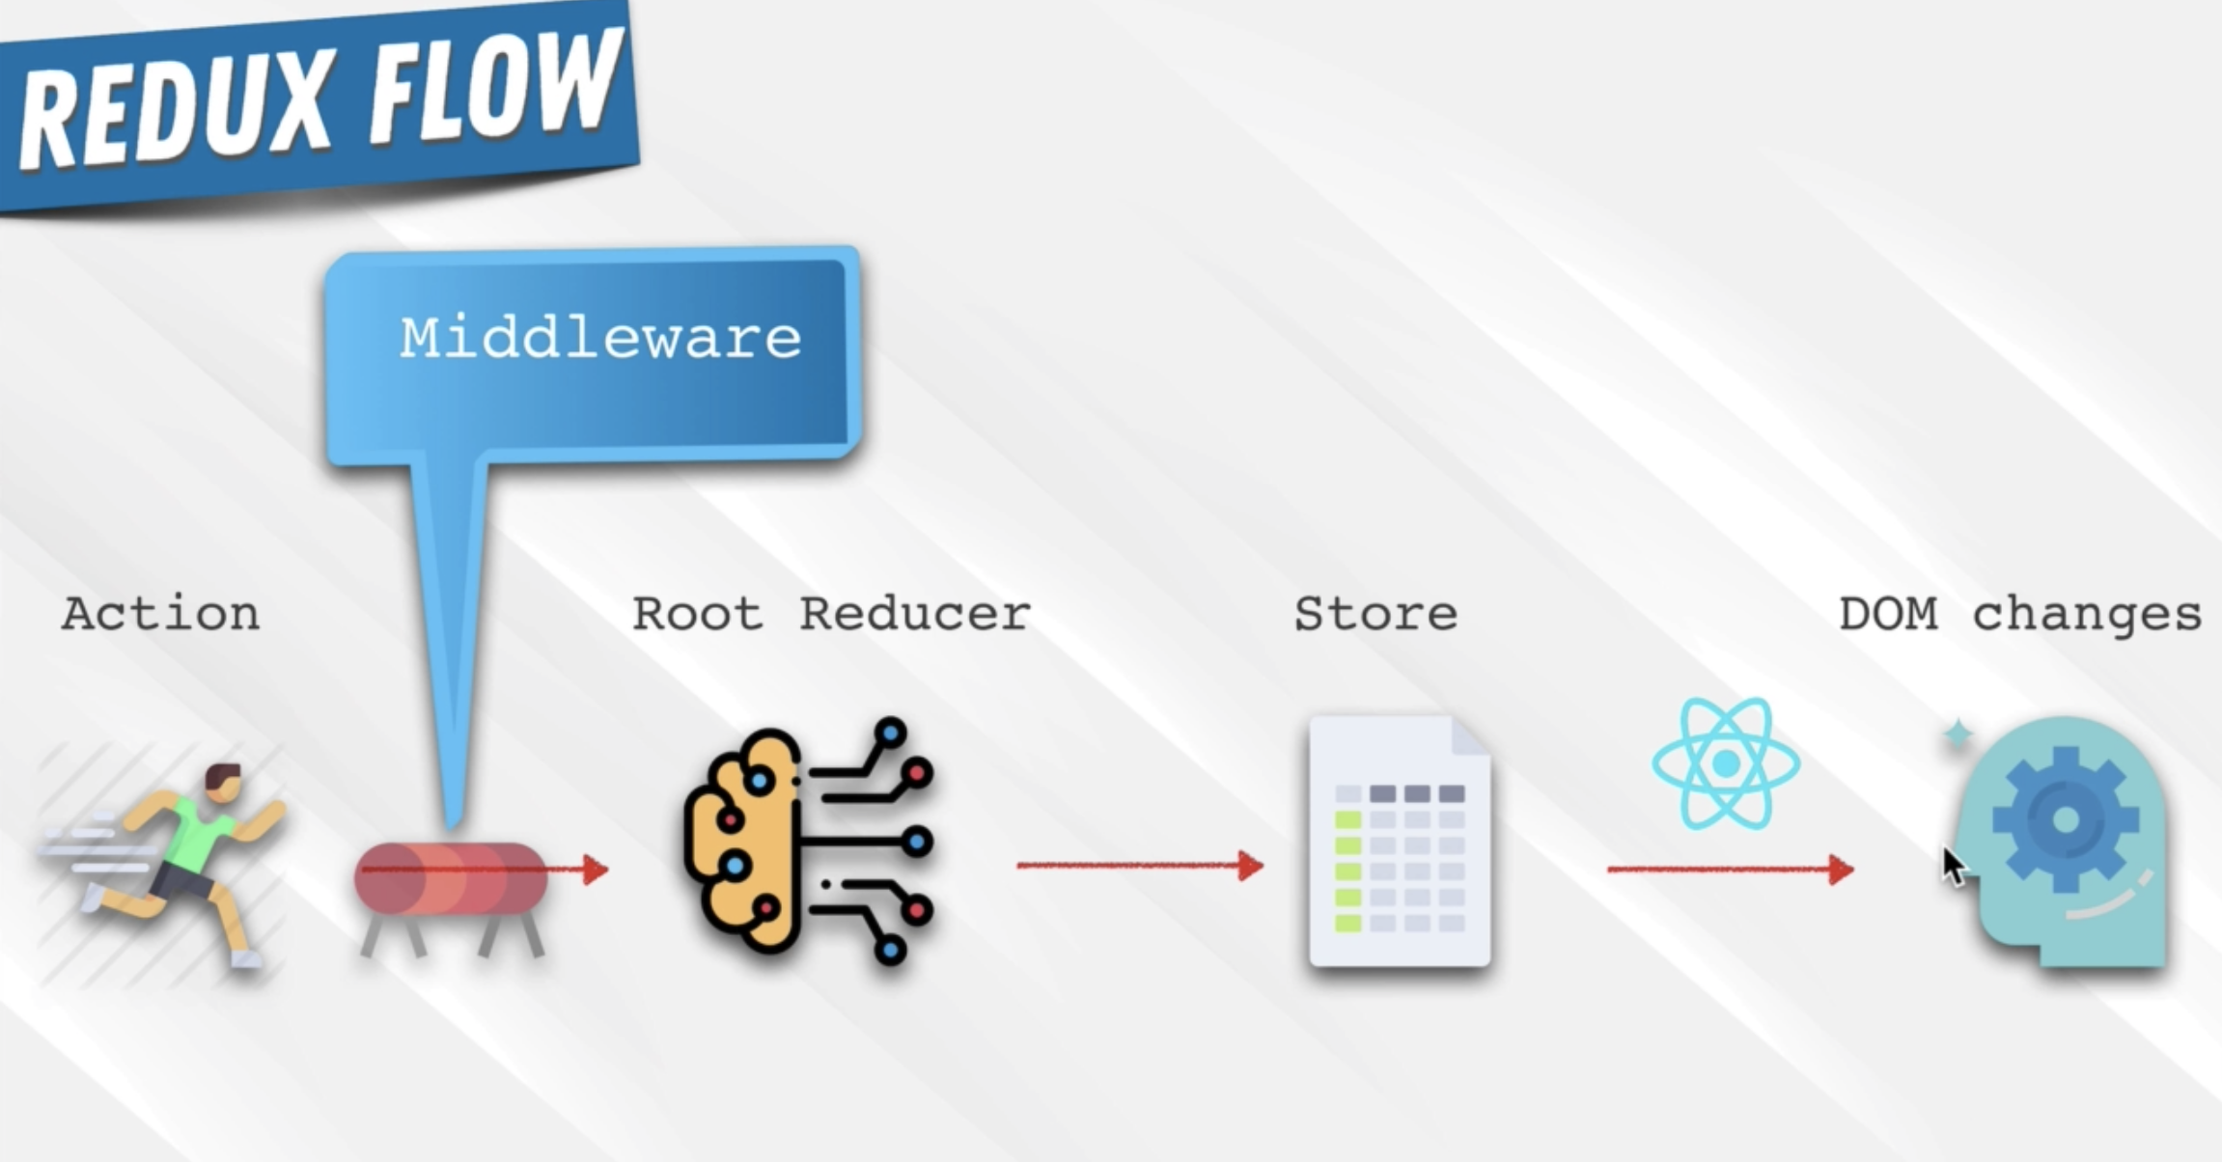

b. npm I redux redux-logger react-redux

c. Put the { Provider } to index.js from ‘react-redux’. Wrap the whole App so that the whole application will have an

access to all features related to store. It will be the parent of everything.

d. Write the store. Create the redux folder inside the src and create the root-reducer.js inside it.

**i. Root reducer will combine all the reducers in it.**

e. Create the user-reducer.js.

i. Put it inside the user folder.

ii. A reducer is a function that gets 2 properties namely the   
state and action.

iii. The state is an object which represents the initial or last state.

iv. Action is an object which consists of the following:

1. type: which is a string. Type is just a name that tells the specific action.

2. payload = is an action object that could be of anything

v. Assign the initial state: const INITIAL_STATE = { currentUser: null }, put this as the default parameter for state = INITIAL_STATE

vi. Use Switch Statement function to return the value of state base from the action. Default: return state is if there’s no matching action found, then the function will just return the current state.

vii. export default userReducer

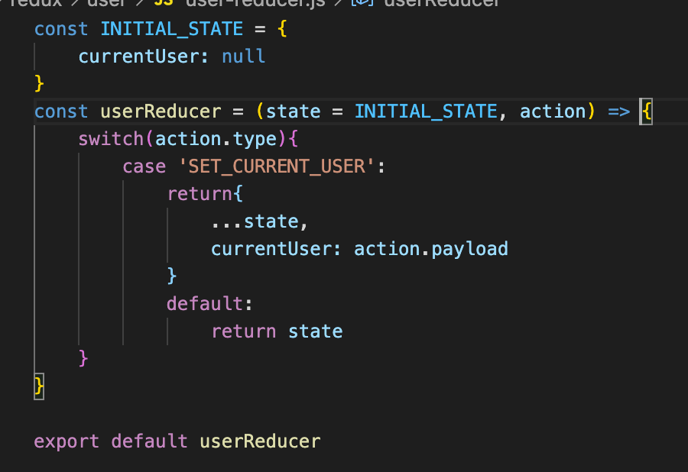

f. bring the userReducer to root-reducer.js

i. import { combineReducers } from ‘redux’

ii. import userReducer from ‘.user/user.reducer

iii. export default combineRedcers and put the userReducer inside the object. assign a key to userReducer

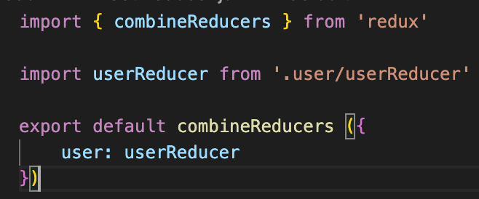

116. Setup Redux 2

a. Create the store

i. create the store.js inside the redux folder

ii. import { createStore, applyMiddleware } from ‘redux’

1. middleware is a function that catch the actions and display it before it reach the root reducer.

2. import logger from ‘redux-logger

iii. import root-reducer from ‘./root-reducer’

b. set up the middlewares

i. const middlewares = [ logger ] <<< results to an array

c. create the store

i. const store = createStore( rootReducer, applyMiddleware(…middlewares) )

d. export default store;

e. bring the store to App.js and pass it as a props in the Provider

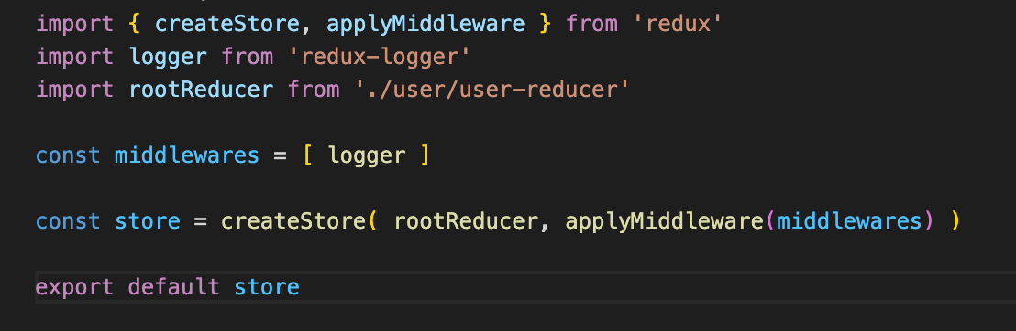 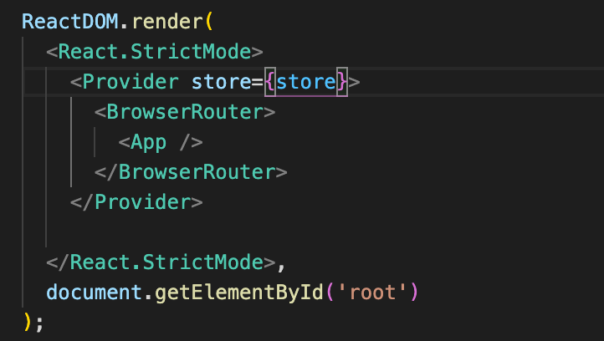

f. Implement | Create Action – so that the redux can now start to store the value of user into the userReducer and out

to the <App>

i. create the action that will trigger the SET_CURRENT_USER inside the user-reducer.js

ii. create the user-actions.js inside the /redux/user

iii. action is a function that returns an object that consist of the type and payload

1. SET_CURRENT_USER should be the same as with the user-reducer as this is the string value expected

by the reducer.

2. user is an object that came from <App>. It’s either the userAuth or the snapShot

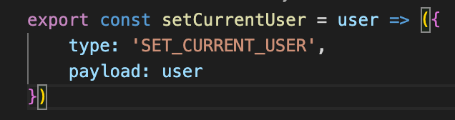 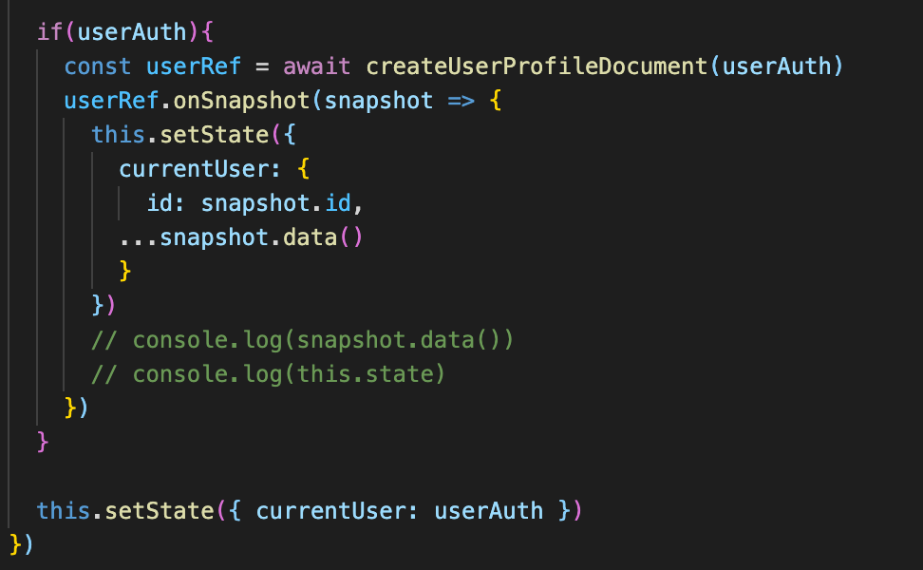

117. connect() and mapStateToProps

a. use the userReducer to <App> at the <Header> as the <Header is using the currentUser from the <App>

b. import { connect } from ‘react-reducer’ at the header.js

1. connect is an HOC that let’s the components access the features of redux

2. connect takes 2 functions; 1 is optional ( mapStateToProps ) and the 2nd is the upgraded component

(Header)

c. mapStateToProps can be of any name.

1. It will be the function that will allow the <Header> to access the state with the state being the

reducer (root-reducer.js)

2. it’s an object that will have the name of the properties will be the actual properties that needs to pass in.

3. It will get the ‘state‘ which is the root reducer, the top level root reducer.

i. currentUser: state.user.currentUser

1. currentUser is the name of the property

2. state – is the root reducer

3. user (key) is a property of the root-reducer that will give the userReducer

4. currentUser is the property returned in the user-reducer.js

d. Remove the passing of the props to <Header> in the <App>

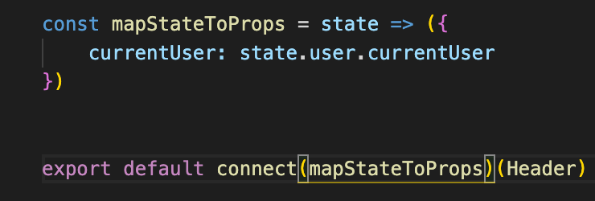

118. mapDispatchToProps

a. Update the <App> so that it can update the reducer value base from SET_CURRENT_USER of the

user.actions.js.

b. import { connect } from ‘react-redux’ & import { setCurrentUsr } from ‘./redux/user/user.actions.js’

c. export default connect(null, mapDispatchToProps)(App) <<< null because the currentUser is not needed in

the App

d. mapDispatchToProps is a function that gets the dispatch property and will return

e. setCurrentUser can now replace the constructor and currentUser

f. replace the this.setState by currentUser

g. destructure the const { setCurrentUser } = this.props

h. remove the this.setState({currentUser:userAuth}) >>> setCurrentUser(userAuth)

i. at this point the logger is now displaying the actionin the console

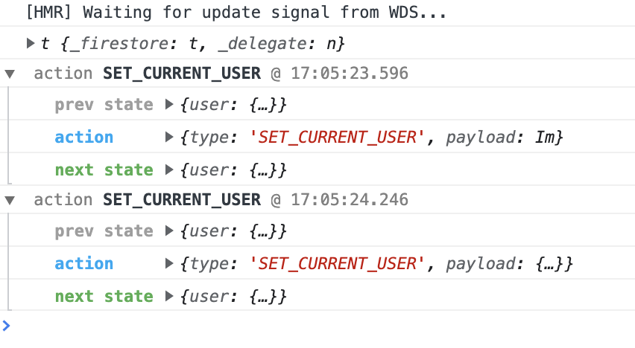

119. User Redirect and User Action Type – this fir the user not to see the sign in page if there’s a successful signin.

a. 2 items needed:

i. At App.js, import { Redirect } from ‘react-router-dom

II. the user from root.reducer.js

1. use mapStateToProps = ({ user }) => ({ currentUser: user.currentUser })

2. this will grant access and get the state

b. use the ternary operation to evaluate the presence or absence of currentUser and use the render function

to invoke what component needs to be rendered. Do this at the <Route component={SigninAndSignupPage}>



c. Replace the null by mapStateToProps to connect(mapStateToProps, mapDispatchToProps)(App)

d. did the same thing with the SIGN OUT button. If !this.props.currentUser.



e. Improve the SET_CURRENT_USER to make it consistent to all places it can be use

i. create the set.types.js inside the user folder

ii. export const UserActionTypes = { SET_CURRENT_USER: ‘SET_CURRENT_USER }

iii. import UserActionTypes to user.action.js and all its been use

iv. then convert all SET_CURRENT_USER to UserActionTypes.SET_CURRENT_USER

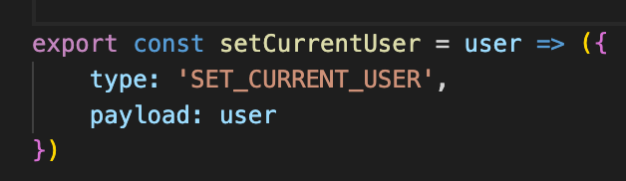 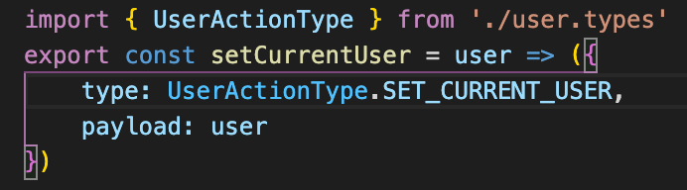

120. Cart Component

a. Get the bag svg

b. create the cart icon component

121. Cart Drop down Component

a. create the cartDropdown component

b. import the <CustomButton>

c. import the <CartDropdown> to <Header> just outside the option. Watch out for the techque for dropdown

component.

122. Implementing redux in cart – this is to show and hide the <CartDropdown> component base in clicking the cart

icon. This method is to make the <CartDropdown> completely independent and reusable anywhere.

a. Create the redux files, cart.reducer.js, cart.types.js and cart.actions.js

b. Create the cartReducer. Set the const INITIAL_SET = { hidden: true }

i. hidden: !state.hidden <<< this provides a toggle functionality rather than setting the state.

c. create the cart.types.js

i. export default CartActionTypes = { TOGGLE_ART_HIDDEN: ‘TOGGLE_CART_HIDDEN’ }

ii. then import this in the cartReducer

d. Create the art.actions.js

i. import the CartActionTypes

ii. no payload is required because state is not being set, instead only a toggle is trying to achieve

iii. type: CartActionTypes.TOGGLE_CART_HIDDEN <<< TCH is the initial string assigned from cartReducer

e. in the <Cart Icon> component, import the cart.actions.js and import { connect } from ‘react-redux’

i. Create the mapDispatchToProps

ii. 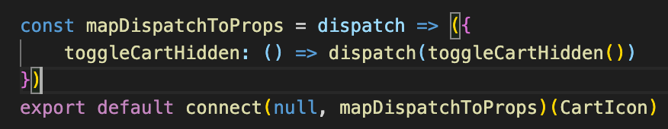

iii. pass the toggleCartHidden to the CartIcon and assign it in the onClick

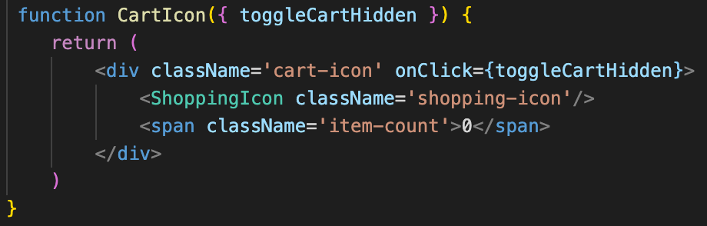

f. Add the cartReducer to the roo-reducer

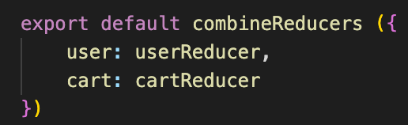

g. Destructure the state in the <Header>

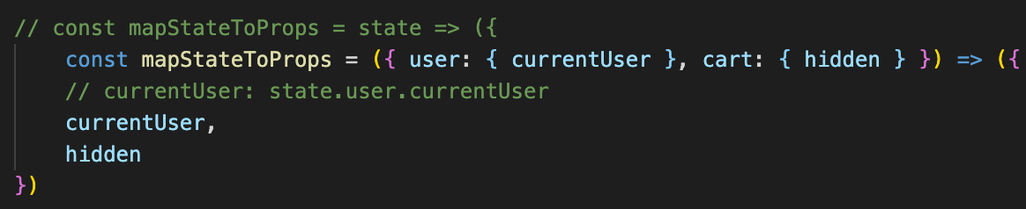

123. Add to cart styling

a. Re-customize the <CustomButton> by dfining theclassNAme=’inveted’

b. Import <CustomButton> in the <CollectionItem />

c. re-style the <CollectionItem /> after the inclusion of the <CustomButton> hide initially the <CustomButton> and put it

inside the <CollectionItem /> box

124. Cart Item Reducer

a. Create the property that needs to set inside the reducer

i. in the cartReducer, add the new property cartItems: []. Use array as vsalue will be added or remove from it

depending on the available data

ii. in the cart.actions.type, add the new cart actions so that the reducer is aware of what is the addItem is to

be made.

1. create the ADD_ITEM: ‘ADD_ITEM’

iii. create a function to add the item whenever the user clicks it

1. add a new case in the cartReducer

2. return an object that all of the state (…state) and cartItems. Include the old and the new (payload)

cartItems that got fired in the array. cartItems: [state.cartItems, action.payload]

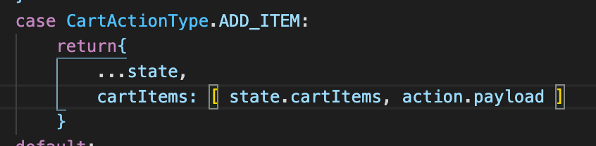

iv. in the cart.actions.js

1. create the new export const addItem = item => {type: CartActionItems.ADD_ITEM, payload: item}

2. 1 is a function that will get the item that needs to be add in the cartItems array. It will return then an

object that consists the ADD_ITEM and the payload

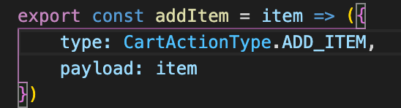

v. Bring the addItem to <CollectionItem > to be able to use this state

i. import { connect } from ‘react-redux’

ii. import { addItem } from ‘../redux/cart/cart.actions’

iii. create the mapDispatchToProps because it needs to dispatch the addItem

iv. addItem: is the imported function from cart-actions.js

v. whenever there’s an addItem, it will get the item as the property that will represent the addItem that

was passed in

vi. then dispath the addItem function creator pasing the (Item) as the payload.

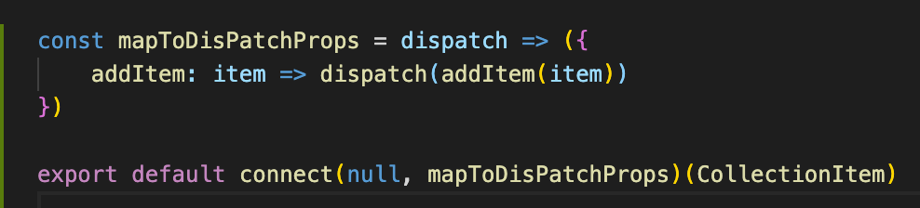

vii. as there’s no need for mapStateToProps as of the moment.

vii. destructure the addItem in the CollectionItem

b. The <CollectionItem > has now access to addItem, It now needs to access the item that the <CollectionItem

> represents in order for the item be dispatch in the addItem

i. Tweak the <CollectionPreview >.

1. pass the whole item to the map in the <CollectionPreview > and pass the item={item}

2.

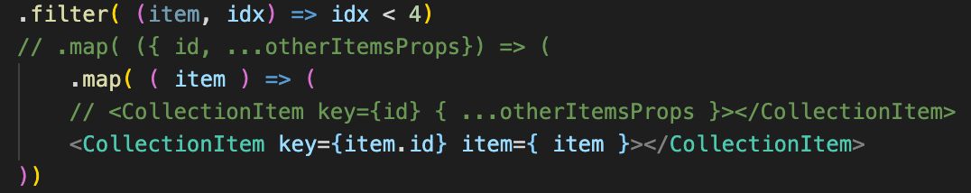

c. back in the <CollectionItem> replace the destructured props by item. Remove the id as its not being use.

d. destructure the item, price, imageUrl = item. Then we can use now the item

e. pass the item as a props in the function of the <CustomButton onClick={() => addItem(item)}

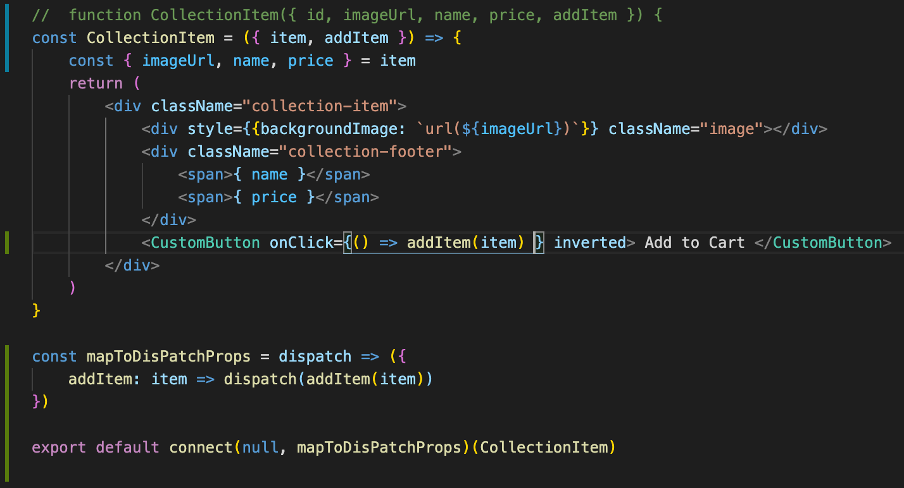

f. the ADD_ITEM action is now being fired and the cart is being updated though same items kept on

appearing.

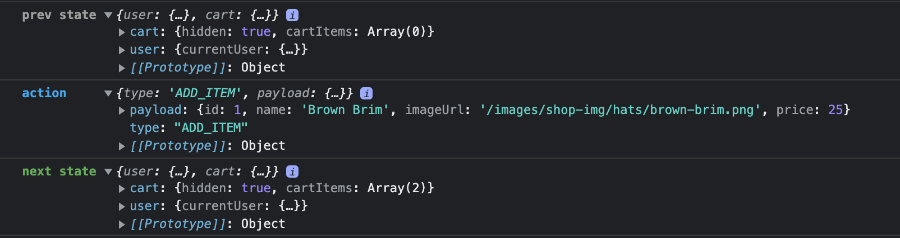

g. pls note that the item used in the addItem function creator comes from the <CollectionPreview> items state

which was filetered then map

125. Adding multiple items to cart – grouping the cartItems inside the cart reducer. Create a utility that will Make sure that the

object pass will result to change only in the properties and will not make the component to re-render.

Utility function will allow to keep functions that may be needed in different locations.

a. create the cart.utils.js in cart folder

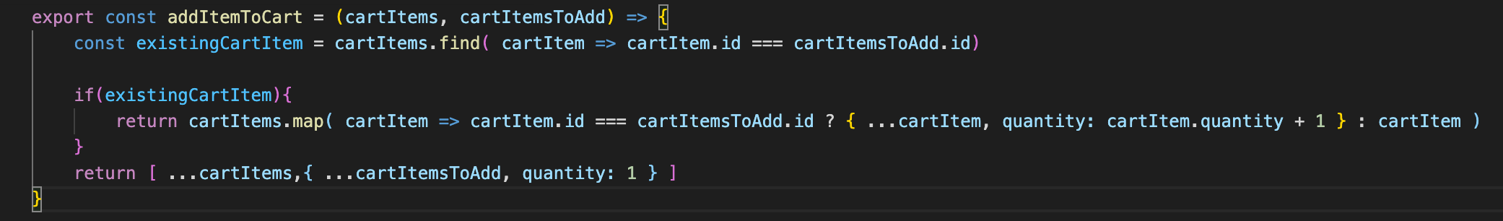

b. import the addItemToCart in cart.reducer

i. in the case, replace the value of cartItems by the addItemToCart( state.cartItems, action.payload )

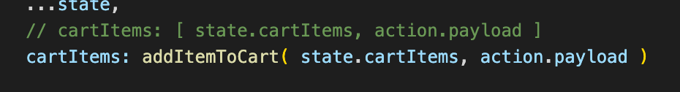

c. replace the shop.data.js due to the id error

d. the quantity is now updating

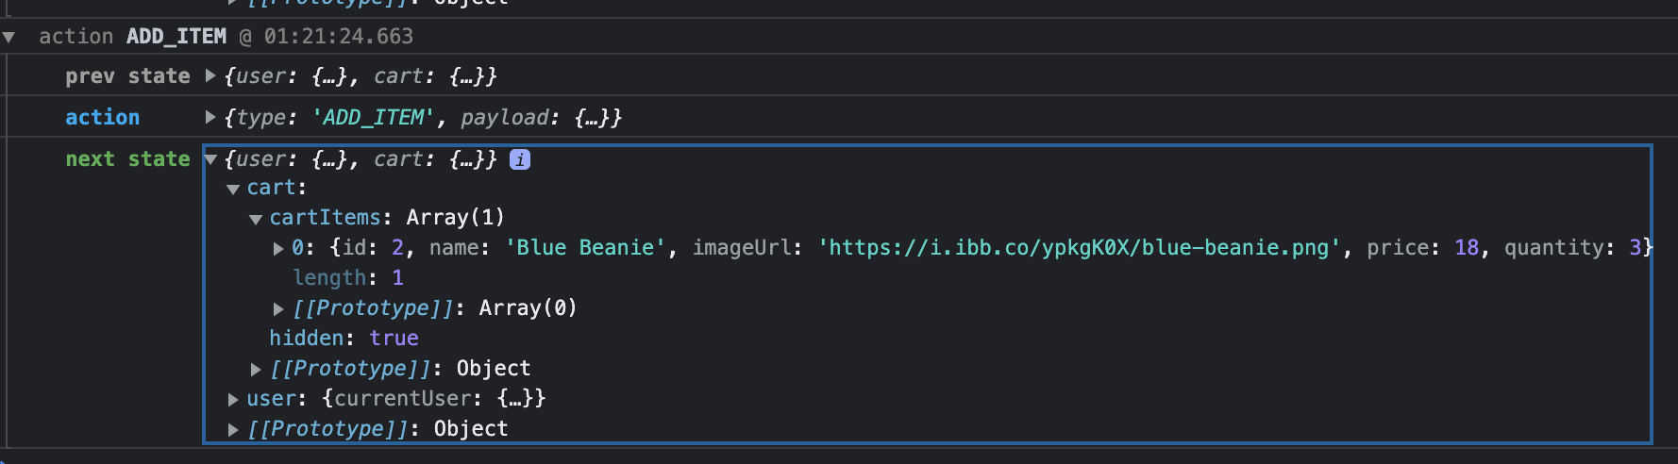

127. Optional find()

128. Cart Item Component – this will showcase the use of cartItems state from cart-reducer.js, pulled it out and use in the <CartDropdown /> and <CartItems /> components.

a. Create the functional <CartItem />

b. Destructure the item and get the imageUrl, price, quantity and name

c. Style the component

d. import the <CartItem /> to <CartDropdown />

e. At >CartDropdown />

1. Import { connect }, this is to have an access from the cartItems state from cart-reducer.js

2. create the const mapStateToProps = ({ cart: { cartItems } }) => cartItems:

3. then connect: export default connect(mapStateToProps)(CartDropdown)

4. destructure the cartItems in CartDropdown function: const CartDropdown = ({ cartItems }) then map it

5. { cartItems.map(cartItem => <CartItem key={ cartItem.id } item={ cartItem } />) }

129. Reduce()

a. Reduce() is great to use when the equation needs to result in 1 value from the array

b. if it needs to re-itirate the return value from each iteration of the array properties

c. array is a function that has 2 arguments

1. a function that has 2 parameters which is the accumulator and the element

2. initial value

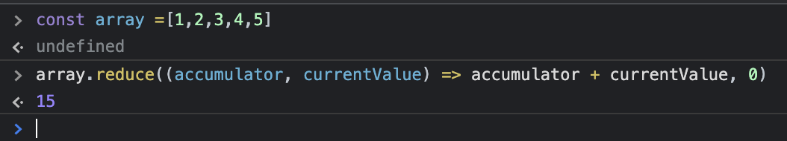

3. From here, initial value of accumulator = 0 and initial value of currentValue = 1(from array). Thus, = 0 + 1

4. 1 will be the latest accumulator value + the currentValue of 2(from array) = 1 + 2 = 3 and so on. Thus the   
result of equation = 15

130. Selectors in Redux – this is t display the number of items in the <CartDropDown />

a. in the <CartIcon />

1. use mapStateToProps and use the reduce() method to have the total quantity of items inside the

<CartDropdown />

2. Destructure the <CartIcon /> and add the itemCount

3. then use it in the item-count span

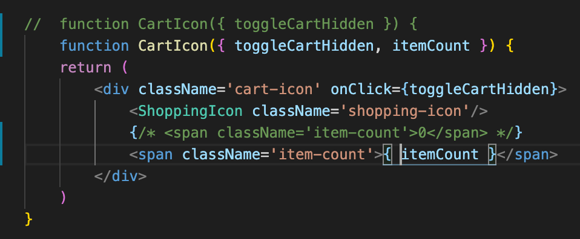

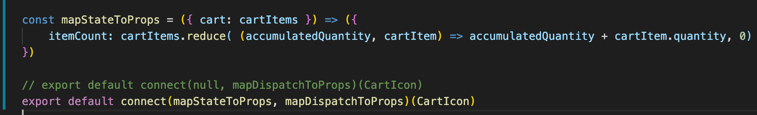

4. the <CartIcon /> can now display the quantity

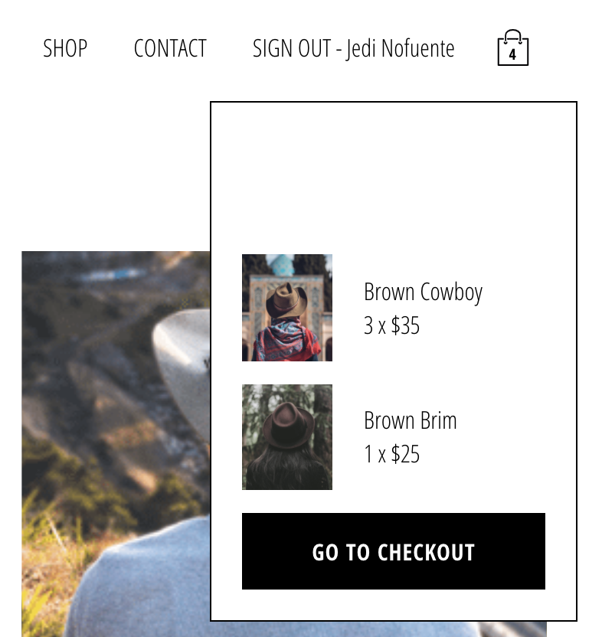

b. This coding is the implementation of selector

1. selector is getting a piece of data from the state. In this case the state is the cartItems and it only need the

piece of the state or data which is the quantity.

2. the caveat here is that the app is always calling the mapSTateToProps and a performance concern, as

there’s no need to re-render the component everytime there’s a state change, especially if the component

doesn’t care about the said state change

3. To address this issue is to store the state in a cache or Memoization which is the caching of the selctor

Value

4. Memoization can make the component reusable

131. Memoization



a. Caching is storing of values, it speeds up programs and hold piece of data in an easy access box

b. it cached the return value of a function

c. syntax as below:

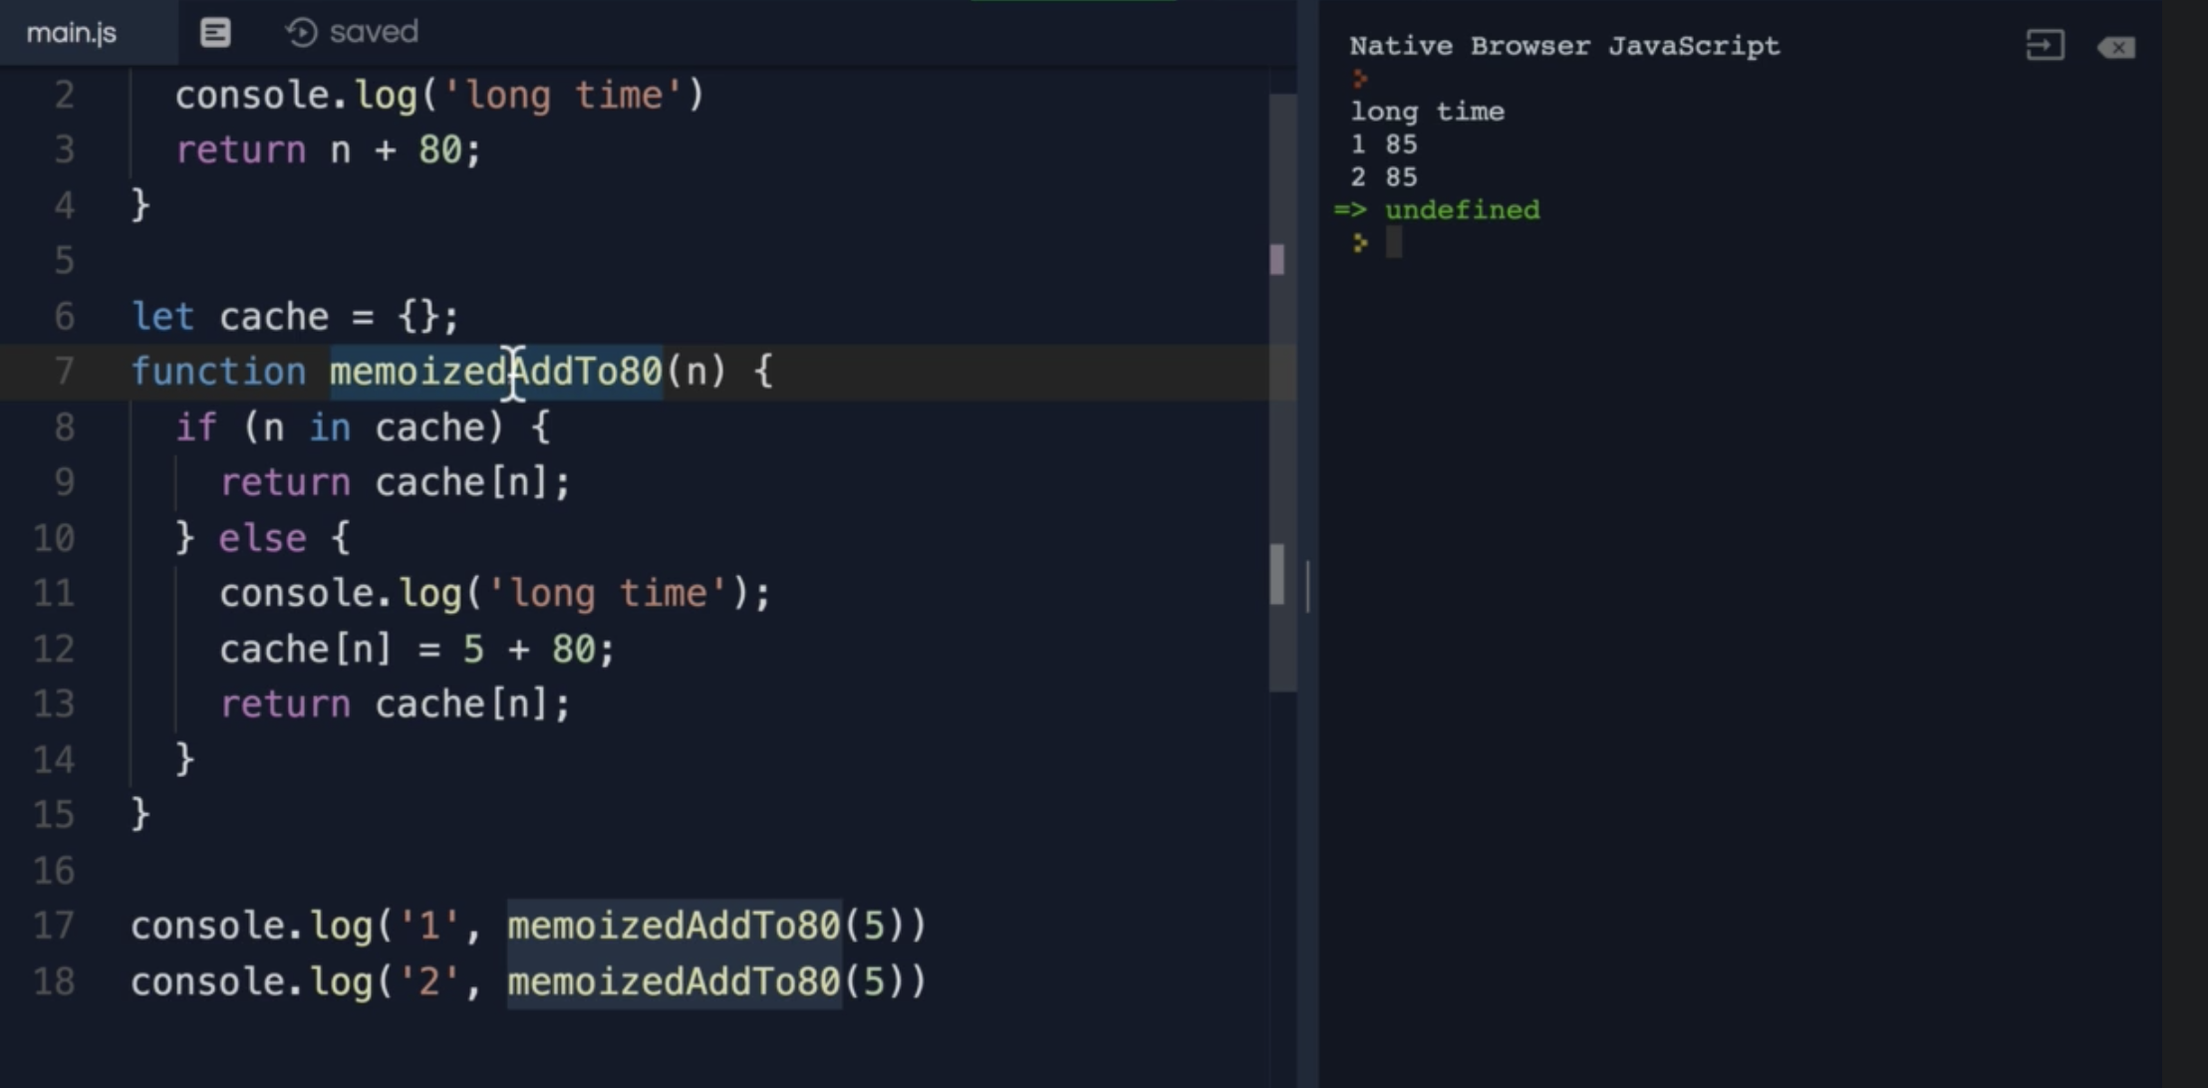

d. It skips the recalculation if same value is presented, instead of re-calculation, it uses the value stored in the cache

132. Reselect library

a. npm I reselct

b. create the car.selectors.js inside the cart folder. This is because for the itemCount to be re-usable just in case other

components need this piece of state

c. types of selector

1. input selector – doesn’t use createSelector

2. output selector – use input and createSelector

d. at cart.selector.js; import { createSelector ] from ‘reselect’

1. create the input selector const selectCart = state => cart.cartItems <<<< it’s taking only a piece of state from

the cart which is the cartItems

2. create the output selector export const selectCartItems = createSelector([ selectCart ], cart => cartItems) <<< this is the main output selector

3. create the output selector for the itemCount. export const selectCartItemsCount = createSelector([selectCartItems], cartItems => cartItems.reduce((accumulatedQuantity, + cartItem) => accumulatedQuantity + cartItem.quantity, 0) <<< this came from <CartIcon />

e. in the <CartIcon /> import { selectCartItemsCount } from ‘../../redux/cart/cart.selectors’

1. use the selectCartItemsCount in the itemCount: and pass the whole state to be evaluated

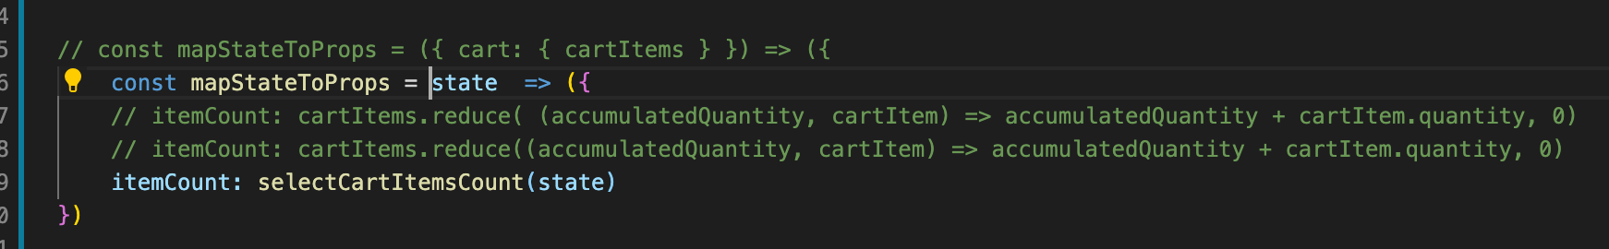

f. this made the code to work the same, except that the value of the <CartIcon /> is memorized

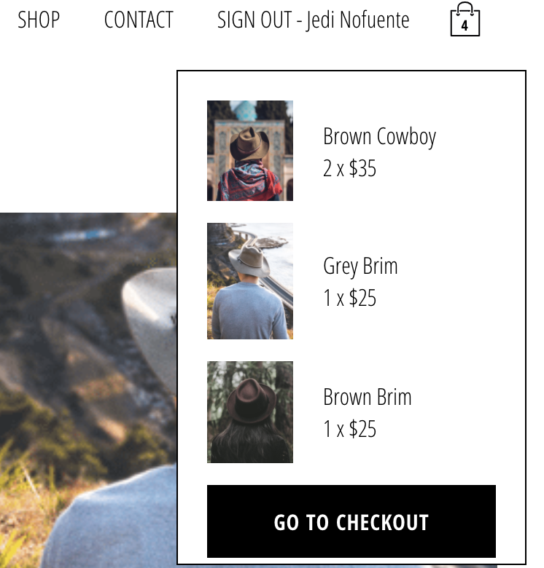

g. implement the same method of memorization in the <CartDropDwon />

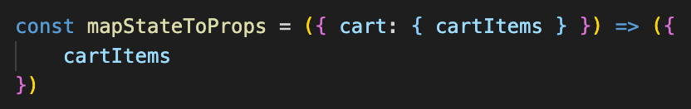

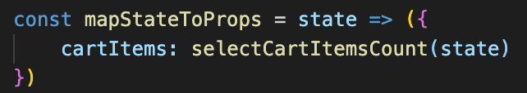

133. Quick correction

134. User selector – convert user mapStateToProps to reselct

a. create the user.selection.js

b. at <Header />, memorize the currentUsser

1. create the selector for currentUser

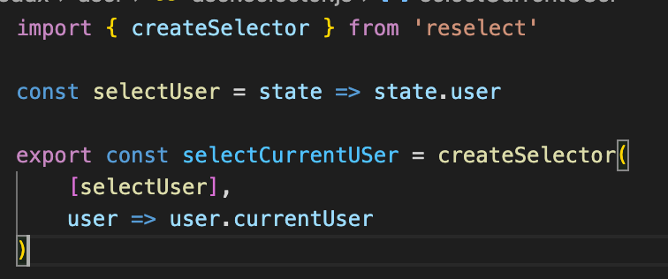

c. create also for the cartHidden at the cart.selector.js

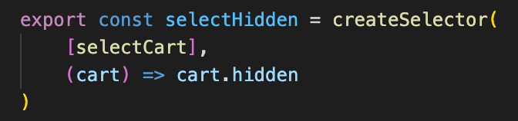

d. at the <Header />

a. import the { createStructuredSelector } from ‘reselect’

b. import { selectCartHidden } from ….cart.select.js

c. import { selectCurrentUser } from …. user.select.js

d. pass the state to the selector

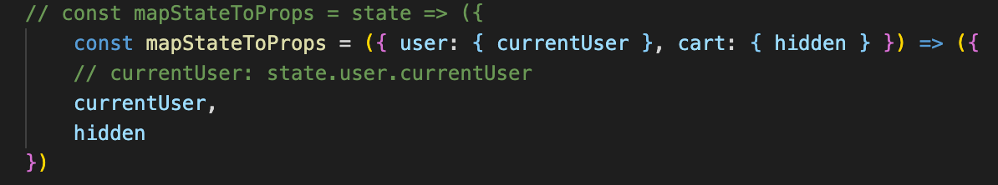

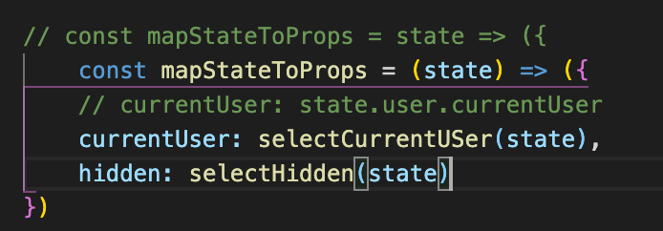

e. this is where the application of createStructuredSelector is

 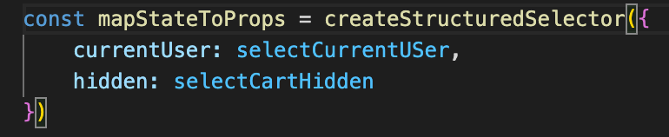

The state was replaced by createStructuredSelector

e. Use also the createStructuredSelector in the other components like the <App />

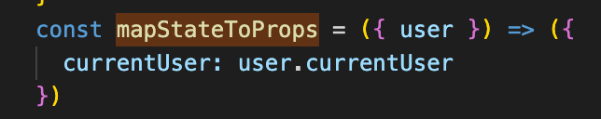 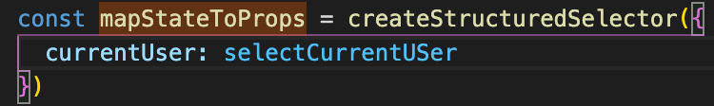

f. Implement also the createStructuredSelector in <CartDropdown />

g. Implement also the createStructuredSelector in <CartIcon />

h. Below syntax can also be use from multiple array or input selectors

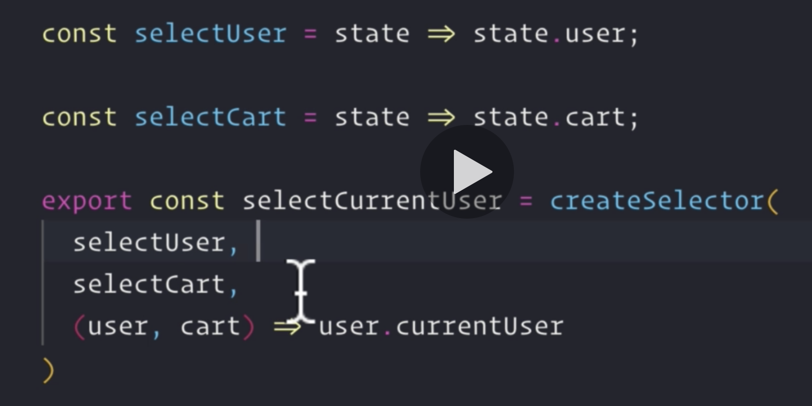

135. Check out page

a. Finish first the <CartDropdown /> by displaying a message if there’s no items in it.

1. in the <CartDropdown />, conditionally render a span or the cartItems has a length of >0

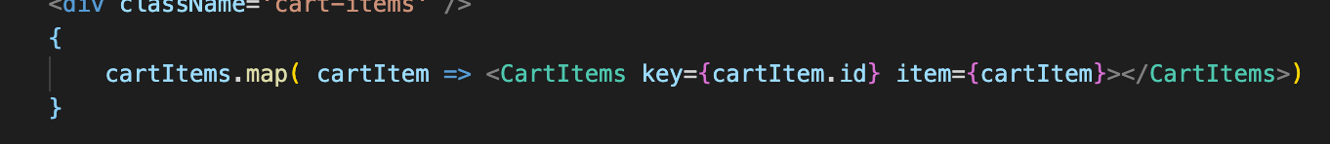

b. create the functional <CheckOut />, create the folder and files for it

c. Bring it to the <App />

d. use withRouter() and take the props history to the component

e. in the <CustomButton onCLick={ () => history.push(/checkout) }/>



Side Note: Type coercion

== > check for the value

=== > check for value and type

6 things that evaluate to false

1. 0

2. false

3. undefined

4. null

5. Nan

6. “”

136. Checkout Page 2

a. create the <Checkout />

b. style the page

c. import { connect ], { createStructuredSelector } and { slectCartItems }

d. create the mapStateToProps

e. at the cart.slector.js

1. create the selectCarTotal

2. export it to the <Checkout />

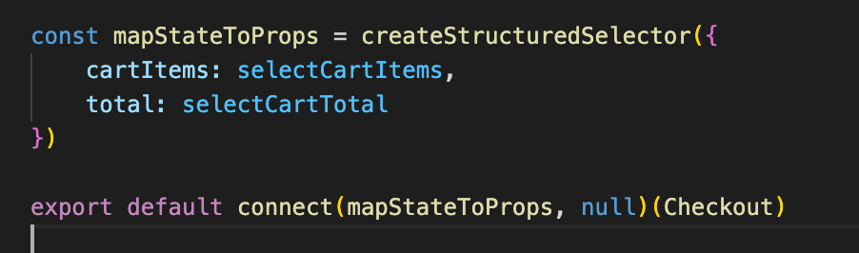

f. destructure the cartItems and total

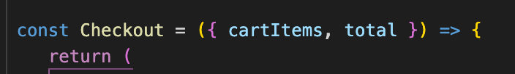

137. Extensible Code

138. Dispatch Action Shorthand – trigger a toggle when “GO TO CHECKOUT” button is click;

a. in <CartDropdown />, bring in the { toggleCartHidden }

b. destructure the dispatch

c. note that the dispatch function is automatically passed in as a destructure ibject even if it was not called in

connect().

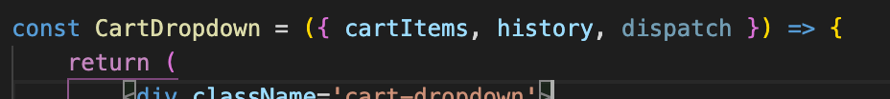

d. toggleCartHidden is now active after pressing the GO TO CHECKOUT

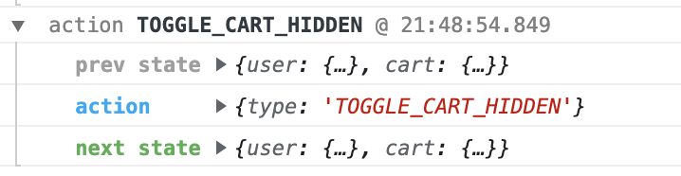

139. Checkout item component – this will use the cartItems that was stored in the state, similar on how it was pulled out for

<CartDropdown />. This is to be map in <Checkout /> page.

a. create the functional <CheckoutItem />

1. use UTF-8 winding for the remove-button icon #&10005 for X

2. Pass the cartItem as a props, destructured and get the name, imageUrl, price and quantity

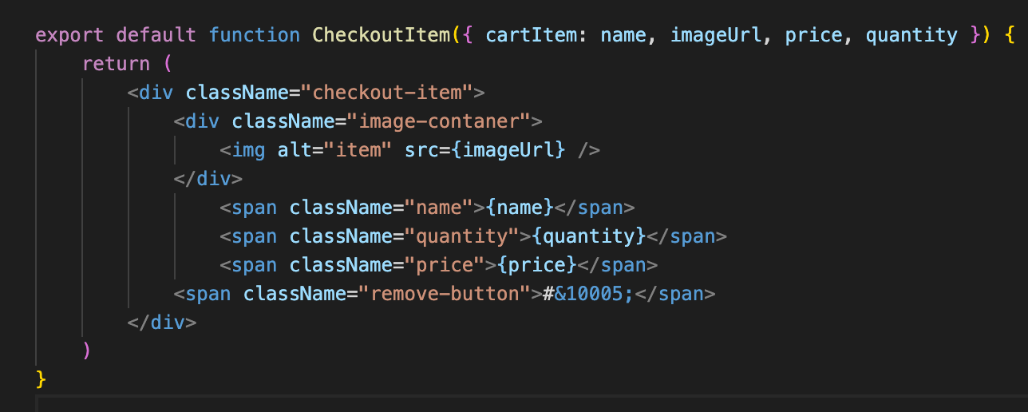

3. Bring it to the <Checkout /> page

1. replace as the cartItem.name by the <CheckoutItem />



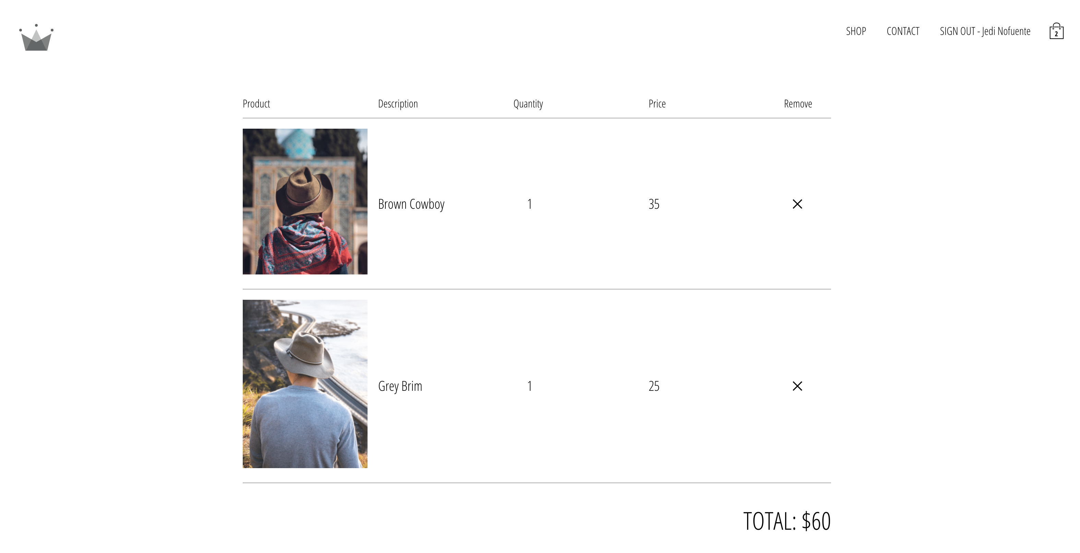

140. Remove items from cart

a. at the cart.types.js, create a new action type CLEAR_ITEM_FROM_CART: “CLEAR_ITEM_FROM_CART”

b. at the cart.actions.js, create a new action that dispatch the new CLEAR_ITEM_FROM_CART

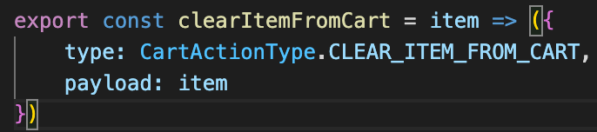

c. Update the cart.reducer.js so that the reducer removes the appropriate items from the array. Create the new case

CartActionTypes.CLEAR_ITEM_FROM_CART that will listen to the new action

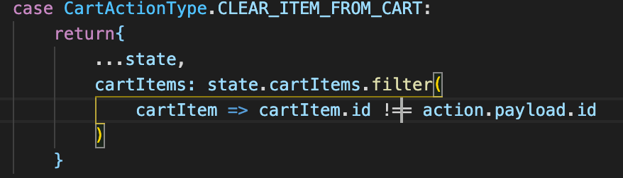

d. bind the new action to <CheckoutItem />. Import { clearItemFromCart }.

1. create the mapDispatchToProps = dispatch => ({ clearItem: item => dispatch(clearItemFromCart(item)) })

2. Get the item by restructuring the properties as below and pass the clearItem as the props

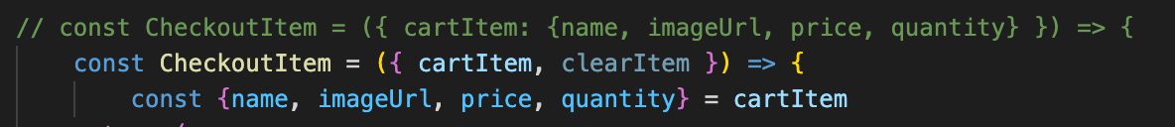

3. Assign the onClick={() => clearItem(cartItem)} to remove-button



4. it will now delete the item

141. Remove items at Checkout – needs to be able to add or decrease quantity and delete the item if quantity reaches 0.

a. add the add | decrease arrows n <CheckoutItem />. Use also the UITF-8 windings. Style the components afterwards

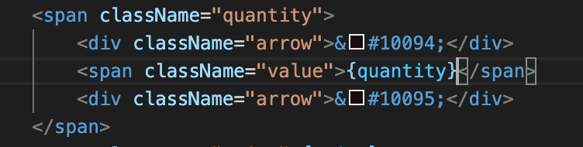

b. Bind the functionality in the left and right arrow.

c. in the cart.actions.js, add a new action type that will REMOE_ITEM: “REMOVE_ITEM”

d. in the cart.actions.js, create the const export removeItem

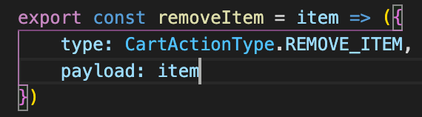

e. in the cart-reducer, create the new case: CartActionTypes.removeItem

f. in the cart-utils.js, create the decrease function

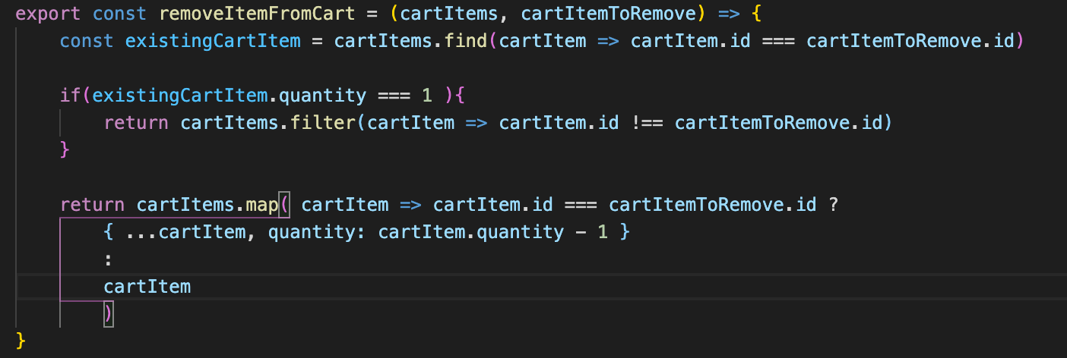

g. bring the removeItemFromCart to cart-reducer.js

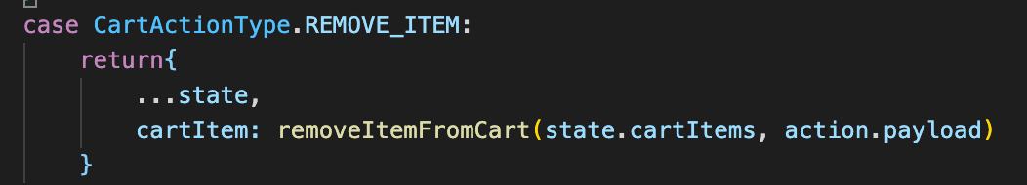

h. bring addItem and removeItem to <CheckoutItem />. Dispatch it to mapDispatchtoProps

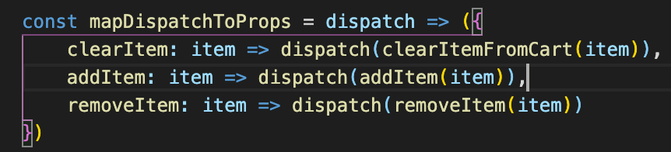

i. bind this to onClick of the arrows

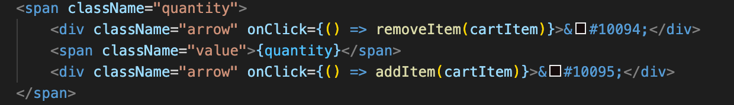

j. it can now reduce and add item as well as to delete item if the quantity = 1.

Section 9 – Session Storage and Persistence